

**Mini Project Report on**

**Library Management System**

**Version 1.0**

**18/04/2017**

**Submitted By**

**Md. Fokhrul Islam Parvez**

**Id: - 162-35-1700**

**Section: - C**

**Deferment of Software engineering**

**Daffodil international university**

**Submitted To**

**Md. Shohel Arman Shuvo**

**Lecturer**

**Deferment of Software engineering**

**Daffodil international university**

**Copyright @2017 Parvez**

**ACKNOWLEDGEMENT**

We take this occasion to thank Allah, almighty for blessing us with his grace and taking our endeavor to a successful culmination. We extend our sincere and heartfelt thanks to our course teacher, **Md. Shohel Arman Shuvo** , for providing us with the right guidance and advice at the crucial junctures and for showing me the right way. We also take this opportunity to express a deep sense of gratitude to our respected ma’am, **Ms. Afsana Begum** and **Ms. Lamisha Rawshan** for their cordial support, valuable suggestions and guidance. We extend our sincere thanks to our respected Head of deferment, **Dr. Touhid Bhuiya**, for allowing us to use the facilities available. We would like to thank the other faculty members also, at this occasion. Last but not the least, we would like to thank our friends and family for the support and encouragement they have given us during the course of our work.

**TABLE OF CONTENTS**

1. Introduction …………………………………………………………………………………………………………………….....…… 4
   1. Project aims and objectives …………….………………………………….………………………………………….. 5
   2. Background of Project ……………………………………………………….……………………………………………. 5
   3. Operation Environment ……………………………………………………….……………………………………….… 6
   4. Milestones and Reporting……………………………………………………………………..…………………………. 6
   5. Testing …………………………………………………………………………………………………………………………….. 6
   6. Payment Terms ……………………………………………………………………………………………………………….. 7
   7. Contract us ………………………………………………………………………………………………………………………. 7
2. System Analysis…………………………………………………………………………………………………………………………. 8
   1. Software Requirement specification………………………………………………………………………………… 8
      1. System Description………………………………………………………………………………………………… 8
      2. System Objectives………………………………………………………………………………………………….. 9
   2. System Requirement………………………………………………………………………………………………………… 9
      1. Functional Requirement…………………………………………………………………………………………. 9
      2. Nonfunctional Requirement…………………………………………………………………………………… 10
3. User Classes and Characteristics……………………………………….………………………………………………………… 11
   1. Student……………………………………………………………………………………………………………………………… 12
   2. Teacher…………………………………………………………………………………………………………………………….. 12
   3. Admin Panal……………………………………………………………………………………………………………………… 12
4. Requirement Specification…………………………………………………………………………………………………………. 13
5. Use case…………………………………………………………………………………………………………………………………….. 14
6. Use case Description…………………………………………………………………………………………………………….……. 15
7. Entry Relation Diagram…………………………………………………………………………………………………….………… 23
8. Testing………………………………………………………………………………………………………………………….……………. 24
   1. System testing…………………………………………………………………………………………………….……………. 24
   2. Unit Testing………………………………………………………………………………………………………….…………… 25
   3. Integration Testing……………………………………………………………………………………………….…………… 25
   4. Validation Testing………………………………………………………………………………….…………………………. 25
   5. Output Testing…………………………………………………………………………………………………….…………… 26
   6. User acceptance Testing………………………………………………………………………………….……………….. 26
9. Test Result…………………………………………………………………………………………………………..…………………….. 27
10. User Manual……………………………………………………………………………………………………………..……………….. 29
11. Conclusion & Future ……………………………………………………………………………………..…………………………… 36
12. References…………………………………………………………………………………………………………..…………………….. 36

**ABSTRACT**

**Library management system** is a project which aims in developing a computerized system to maintain all the daily work of library .This project has many features which are generally not availiable in normal library management systems like facility of user login and a facility of teachers login .It also has a facility of admin login through which the admin can monitor the whole system .It also has facility of an online notice board where teachers can student can put up information about workshops or seminars being held in our varsity or nearby varsity and librarian after proper verification from the concerned institution organizing the seminar can add it to the notice board .

It has also a facility where student after logging in their accounts can see list of books issued and its issue date and return date and also the students can request the librarian to add new books by filling the book request form. The librarian after logging into his account admin account can generate various reports such as student report, issue report, teacher report and book report

Overall this project of ours is being developed to help the students as well as staff of library to maintain the library in the best way possible and also reduce the human efforts.

1. **INTRODUCTION**

The project title **Library management system** for library management software for monitoring and controlling the transaction in a library. This project **Library management system** is developed in c language. Which mainly focuses on basic operations in a library like adding new member, new books, and updating new information, searching books, deleting books, books issues and facility to borrow and return books.

Library management system is a windows application written for 64-bit windows operating system, design to help users maintain and organize library. Our software is easy to use for both beginners and advanced users, it features a familiar and well thought out an attractive user interface, combined with strong searching inserting and reporting capability. The report generation facility of library system helps to get a good idea of which are the books borrowed by the members, makes users possible to generate reports hard copy.

* 1. **PROJECT AIMS AND OBJECTIVES**

The project aims and objectives that will be achieved after completion of this project are discussed in this subchapter. The aims and objectives are as follows:

* book issue
* Book add
* Book Delete
* Request column for librarian for providing new books
* A separate column for digital library
* Student login page where student can find books issued by him/her and date of return.
* A search column to search availability of books
* A teacher login page where teacher can add any events being organized in the college
* and important suggestions regarding books.
  1. **BACKGROUND OF PROJECT**

Library Management System is an application which refers to library systems which are generally small or medium in size. It is used by librarian to manage the library using a computerized system where he/she can record various transactions like issue of books, return of books, addition of new books, addition of new students etc.

Books and student maintenance modules are also included in this system which would keep track of the students using the library and also a detailed description about the books a library contains. With this computerized system there will be no loss of book record or member record which generally happens when a non computerized system is used.

In addition, report module is also included in Library Management System. If user’s position is admin, the user is able to generate different kinds of reports like lists of students registered, list of books, issue and return reports.

All these modules are able to help librarian to manage the library with more convenience and in a more efficient way as compared to library systems which are not computerized.

* 1. **OPERATION ENVIRONMENT**

|  |  |
| --- | --- |
| Processor | Intel Core i7 or Better Performance |
| Operating System | Windows 10 |
| Memory | 8 GB Ram or more |
| Hard Disk Space | 1 TB |
| Database | My SQL |

* 1. **MILESTONES AND REPORTING**

|  |  |  |  |
| --- | --- | --- | --- |
| **Milestone** | **Tasks** | **Hours** | **Date** |
| 1 | Analysis | 89 | 02/02/17 |
| 2 | Development | 130 | 15/02/17 |
| 3 | Testing | 40 | 09/03/17 |
| 4 | Deployment | 60 | 25/03/17 |

* 1. **TESTING**

The testing process shall be as follows:

* Unit Testing
* Integration Testing
* Functional Testing
* System Testing
* Performance Testing
* Regression Testing
* User/Acceptance Testing
* Pilot/Field Testing

Installation or Production Testing

* 1. **PAYMENT TERMS**

We propose the following payment terms:

* 30% (30%)

Paid on acceptance of this proposal and signing of our software development agreement.

* 20% (50%)

Paid at completion of Milestone 1.

* 25% (75%)

Paid at completion of Milestone 2.

* 15% (90%)

Paid at completion of Milestone 3.

* 10% (100%)

Paid at completion of Milestone 4.

* 1. **CONTACT US**

You can get in touch with us in any of the below ways:

Md. Fokhrul Islam Parvez

Email: parvezdiu16@gmail.com

Phone : +8801726407234

**If you would like to proceed with our proposal then you can sign the first page and return a copy to us by email. In any case please feel free to call us to discuss the quote, request more information or for any other reason.**

**We look forward to hearing from you soon**!

1. **SYSTEM ANALYSIS**

In this chapter, we will discuss and analyze about the developing process of Library Management System including software requirement specification (SRS) and comparison between existing and proposed system . The functional and non functional requirements are included in SRS part to provide complete description and overview of system requirement before the developing process is carried out. Besides that, existing vs proposed provides a view of how the proposed system will be more efficient than the existing one.

* 1. **SOFTWARE REQUIREMENT SPECIFICATION**
     1. **GENERAL DESCRIPTION**

PRODUCT DESCRIPTION:

Library Management System is a computerized system which helps

user(librarian) to manage the library daily activity in electronic format. It reduces

the risk of paper work such as file lost, file damaged and time consuming.

It can help user to manage the transaction or record more effectively and timesaving.

PROBLEM STATEMENT:

The problem occurred before having computerized system includes:

* File lost

When computerized system is not implemented file is always lost because of human Environment. Some times due to some human error there may be a loss of records.

* File damaged

When a computerized system is not there file is always lost due to

some accdent like spilling of water by some member on file accidentally. Besides some natural disaster like floods or fires may also damage the files. Division Of Computer Science And Engineering Page 10

* Difficult to search record

When there is no computerized system there is always a difficulty in searching of records if the records are large in number.

* Space consuming

After the number of records become large the space for physical storage of file and records also increases if no computerized system is implemented.

* Cost consuming

As there is no computerized system the to add each record paper will be needed which will increase the cost for the management of library.

* + 1. **SYSTEM OBJECTIVES**
* Improvement in control and performance

The system is developed to cope up with the current issues and problems of library. The system can add user, validate user and is also bug free.

* Save cost

After computerized system is implemented less human force will be required to maintain the library thus reducing the overall cost.

* Save time

Librarian is able to search record by using few clicks of mouse and few search keywords thus saving his valuable time.

* 1. **SYSTEM REQUIREMENTS**
     1. **NON FUNCTIONAL REQUIREMENTS**

1. **Product Requirements**

EFFICIENCY REQUIREMENT

When a library management system will be implemented librarian and user will easily acess library as searching and book transaction will be very faster .

RELIABILITY REQUIREMENT

The system should accurately performs member registration ,member validation , report generation, book transaction and search

USABILITY REQUIREMENT

The system is designed for a user friendly environment so that student and staff of library can perform the various tasks easily and in an effective way.

* + 1. **FUNCTIONAL REQUIREMENTS**

1. **NORMAL USER**
   1. **USER LOGIN**

Description of feature

This feature used by the user to login into system. They are required to enter user id and

password before they are allowed to enter the system .The user id and password will be verified

and if invalid id is there user is allowed to not enter the system.

**Functional requirements**

-user id is provided when they register

-The system must only allow user with valid id and password to enter the system

-The system performs authorization process which decides what user level can acess to.

-The user must be able to logout after they finished using system.

* 1. **REGISTER NEW USER**

Description of feature

This feature can be performed by all users to register new user to create account.

**Functional requirements**

-System must be able to verify information

-System must be able to delete information if information is wrong

* 1. **REGISTER NEW BOOK**

Description of feature

This feature allows to add new books to the library

**Functional requirements**

-System must be able to verify information

-System must be able to enter number of copies into table.

- System must be able to not allow two books having same book id.

* 1. **SEARCH BOOK**

DESCRIPTION OF FEATURE

This feature is found in book maintenance part . we can search book based on book id ,

book name , publication or by author name.

**Functional requirements**

- System must be able to search the database based on select search type

- System must be able to filter book based on keyword enterd

- System must be able to show the filtered book in table view

* 1. **ISSUE BOOKS AND RETURN BOOKS**

DESCRIPTION OF FEATURE

This feature allows to issue and return books and also view reports of book issued.

**Functional requirements**

-System must be able to enter issue information in database.

-System must be able to update number of books.

- System must be able to search if book is available or not before issuing books

-System should be able to enter issue and return date information

1. **USER CLASSES AND CHARACTERISTICS**

There are four type of user and they are-

* Student
* Teacher
* Admin Penal
  1. **Task of Admin Penal**

1. Login into the system.
2. Admin have all power of the system
3. He can monitor the task of all employees
4. Upload Book to the system
5. Remove Books from site.
6. He can see the user info.
7. Can able to edit Book details.
   1. **Task of Student**
8. Sign in or Sign up into the system.
9. Books add
10. Books Search
11. Books Issue
12. See books
13. Edit Books
    1. **Task 0f Teacher**
14. Sign in or Sign up into the system.
15. Books add
16. Books Search
17. Books Delete
18. Issue Books Delete
19. Books Edit
20. See Books List
21. See Issue Books List
22. **Requirement Specification**

We collect the requirement from all stakeholder and now specify the all requirement below-

|  |  |  |  |  |
| --- | --- | --- | --- | --- |
| SRS id | Title | Description | Requirement  type | Priority |
|  |  |  |  |  |
| PRE-001 | Registration | User Must be Registration before 1st time into the system | NFR | HIGH |
| PRE-002 | Login | User have to login the system | FR | HIGH |
| PRE-003 | Add books | Student and Teacher Add any Books | FR | MEDIUM |
| PRE-004 | Search books | User have to Search option | NFR | MEDIUM |
| PRE-005 | See books list | User see books list | NFR | MEDIUM |
| PRE-006 | Edit books | Any books information Edit only Teacher | FR | HIGH |
| PRE-007 | Delete books | Any books Delete only Teacher | NFR | HIGH |
| PRE-008 | Issue Books | Student any Books issue | FR | MEDIUM |
| PRE-009 | Issues books delete | Only teacher use it | NFR | HIGH |
| PRE-010 | Issue books list | See every one. | FR | MEDIUM |

1. **USE CASE**

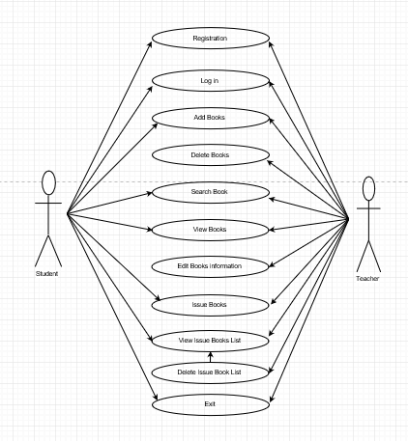

1. **Use Case Description:**

|  |  |  |
| --- | --- | --- |
| Use case | Registration | |
| Goal | Record User information. | |
| Preconditions | N/A | |
| Success End  Condition | The user registration successfully and can manage all the goods. | |
| Failed End  Condition | If user does not enter full user information, the registration will not successful. | |
| Primary Actors; | Admin | |
| Secondary Actors | Main menu | |
| Trigger | N/A | |
| Description / Main  Success Scenario  <the steps of the  scenario from  trigger to goal  delivery and any  clean up after> | step | Action |
| 1 | user need to write her full information |
| 2 | Make sure does not go to next step. |
| 3 | Get a successful notice in the admin panel after sign in. |
| Alternative Flows  <a: condition  causing  branching>  <a1: action or  name of sub use  case> | step | Branching Action |
| 1 | User enter her full information |
| 2 | Make sure her information save in system. |

|  |  |  |
| --- | --- | --- |
| Use case | login | |
| Goal | To make sure Admin login for maintaining the site. | |
| Preconditions | N/A | |
| Success End  Condition | The Admin login successfully and can manage all the goods. | |
| Failed End  Condition | If Admin enters wrong user name or password, the login will not successful. | |
| Primary Actors; | Admin | |
| Secondary Actors | N/A | |
| Trigger | N/A | |
| Description / Main  Success Scenario  <the steps of the  scenario from  trigger to goal  delivery and any  clean up after> | Step | Action |
| 1 | User need to write the user name and password. |
| 2 | Make sure that the password is correct. |
| 3 | Get a successful notice in the admin panel after sign in. |
| Alternative Flows  <a: condition  causing  branching>  <a1: action or  name of sub use  case> | Step | Branching Action |
| 1 | User can also user name for login. |
| 2 | Make sure that name saved in system. |

|  |  |  |
| --- | --- | --- |
| Use case | Add Books | |
| Goal | User add any Books in system | |
| Preconditions | N/A | |
| Success End  Condition | Books will add Successfully to site. | |
| Failed End  Condition | Otherwise does not add book | |
| Primary Actors; | Must be login or registration | |
| Secondary Actors | Book add successfully add notification. | |
| Trigger | N/A | |
| Description / Main  Success Scenario  <the steps of the  scenario from  trigger to goal  delivery and any  clean up after> | step | Action |
| 1 | User need to write book information |
| 2 | Make sure all information |
| 3 | Write a price of each book and if price negotiate able than  mention it |
| Alternative Flows  <a: condition  causing  branching>  <a1: action or  name of sub use  case> | step | Branching Action |
| 1 | Also use a code number for book. |
| 2 | Make sure that code number is unique for each book. |

|  |  |  |
| --- | --- | --- |
| Use case | Delete book | |
| Goal | Delete the information of book that already sold. | |
| Preconditions | It must be use only teacher. | |
| Success End  Condition | Get a removal notice. | |
| Failed End  Condition | Get a error notice. | |
| Primary Actors; | teacher | |
| Secondary Actors | N/A | |
| Trigger | N/A | |
| Description / Main  Success Scenario  <the steps of the  scenario from  trigger to goal  delivery and any  clean up after> | step | Action |
| 1 | Teacher must need to login and enter library code. |
| 2 | Delete the information that not needed or sold. |
| 3 |  |
| Alternative Flows  <a: condition  causing  branching>  <a1: action or  name of sub use  case> | step | Branching Action |
| 1 | User can save the information for next query. |
| 2 | Save it another space. |

|  |  |  |
| --- | --- | --- |
| Use case | Search book | |
| Goal | See all books. | |
| Preconditions | Must be enter books name correctly. | |
| Success End  Condition | Show search books information | |
| Failed End  Condition | Get a error notice. | |
| Primary Actors; | user | |
| Secondary Actors | N/A | |
| Trigger | N/A | |
| Description / Main  Success Scenario  <the steps of the  scenario from  trigger to goal  delivery and any  clean up after> | step | Action |
| 1 | User must need to login. |
| 2 | User have the access to see the info .. |
| 3 |  |
| Alternative Flows  <a: condition  causing  branching>  <a1: action or  name of sub use  case> | step | Branching Action |
| 1 | User can save the information for next query. |
| 2 | Save it another space. |

|  |  |  |
| --- | --- | --- |
| Use case | View Books | |
| Goal | See all books. | |
| Preconditions | N/A | |
| Success End  Condition | Show every books information | |
| Failed End  Condition | Get a error notice. | |
| Primary Actors; | user | |
| Secondary Actors | N/A | |
| Trigger | N/A | |
| Description / Main  Success Scenario  <the steps of the  scenario from  trigger to goal  delivery and any  clean up after> | step | Action |
| 1 | User must need to login. |
| 2 | User have all the access to see the info .. |
| 3 |  |
| Alternative Flows  <a: condition  causing  branching>  <a1: action or  name of sub use  case> | step | Branching Action |
| 1 | User can save the information for next query. |
| 2 | Save it another space. |

|  |  |  |
| --- | --- | --- |
| Use case | Edit Information | |
| Goal | Books information edit. | |
| Preconditions | At first search this book then edit. | |
| Success End  Condition | New information save | |
| Failed End  Condition | Get a error notice. | |
| Primary Actors; | user | |
| Secondary Actors | N/A | |
| Trigger | N/A | |
| Description / Main  Success Scenario  <the steps of the  scenario from  trigger to goal  delivery and any  clean up after> | step | Action |
| 1 | Go to show option and Edit info. |
| 2 | Info will give book detaibe updated. |
| 3 |  |
| Alternative Flows  <a: condition  causing  branching>  <a1: action or  name of sub use  case> | step | Branching Action |
| 1 |  |
| 2 |  |

|  |  |  |
| --- | --- | --- |
| Use case | Issue book | |
| Goal | Books issue for Student. | |
| Preconditions | Must user information enter before issue books | |
| Success End  Condition | Get issue successfully notice. | |
| Failed End  Condition | Get a error notice. | |
| Primary Actors; | user | |
| Secondary Actors | N/A | |
| Trigger | N/A | |
| Description / Main  Success Scenario  <the steps of the  scenario from  trigger to goal  delivery and any  clean up after> | step | Action |
| 1 |  |
| 2 |  |
| 3 |  |
| Alternative Flows  <a: condition  causing  branching>  <a1: action or  name of sub use  case> | step | Branching Action |
| 1 |  |
| 2 |  |

1. **TESTING**

This software explains Test cases for Library management system. Software testing is a critical element of software quality assurance and represents the ultimate review of specification, design and coding. Testing presents an interesting of a system using various test data. Preparation of the test data plays a vital role in the system testing. After preparation the test data, the system under study is tested those test data. Errors were found and corrected by using the following testing steps and corrections are recorded for future references. Thus, series of testing is performed on the system before it is already for implementation.

The development of software systems involves a series of production activities where opportunities for injection of human errors are enormous. Errors may begin to occur at the very inception of the process where the objectives may be erroneously or imperfectly specified as well as in later design and development stages. Because of human in ability to perform and communicate with perfection, software development is followed by assurance activities.

Quality assurance is the review of software products and related documentation for completeness, correctness, reliability and maintainability. And of course it includes assurances that the system meets the specification and the requirements for its intended use and performance. The various levels of quality assurance are described in the following sub sections.

* 1. **SYSTEM TEST**

Software testing is a critical element of software quality assurance and represents the ultimate review of specifications, design and coding. The testing phase involves the testing of system using various test data; Preparation of test data plays a vital role in the system testing. After preparation the test data, the system under study is tested.

Those test data, errors were found and corrected by following testing steps and corrections are recorded for future references. Thus a series testing is performed on the system before it is ready for implementation.

**The various types of testing on the system are**:

* Unit testing
* Integrated testing
* Validation testing
* Output testing
* User acceptance testing
  1. **UNIT TESTING**

Unit testing focuses on verification effort on the smallest unit of software design module. Using the unit test plans. Prepared in the design phase of the system as a guide, important control paths are tested to uncover errors within the boundary of the modules. The interfaces of each of the modules under consideration are also tested. Boundary conditions were checked. All independent paths were exercised to ensure that all statements in the module are executed at least once and all error-handling paths were tested. Each unit was thoroughly tested to check if it might fall in any possible situation. This testing was carried out during the programming itself. At the end of this testing phase, each unit was found to be working satisfactorily, as regarded to the expected out from the module.

* 1. **INTEGRATION TESTING**

Data can be across an interface one module can have an adverse effect on another’s sub function, when combined may not produce the desired major function; global data structures can present problems. Integration testing is a symmetric technique for constructing tests to uncover errors associated with the interface. All modules are combined in this testing step. Then the entire program was tested as a whole.

* 1. **VALIDATION TESTING**

At the culmination of integration testing, software is completely assembled as a package. Interfacing errors have been uncovered and corrected and final series of software test-validation testing begins. Validation testing can be defined in many ways, but a simple definition is that validation succeeds when the software functions in manner that is reasonably expected by the consumer. Software validation is achieved through a series of black box tests that demonstrate conformity with requirement. After validation test has been conducted, one of two conditions exists.

* The function or performance characteristics confirm to specification that are accepted.
* A validation from specification is uncovered and a deficiency created.

Deviation or errors discovered at this step in this project is corrected prior to completion of the project with the help of user by negotiating to establish a method for resolving deficiencies. Thus the proposed system under consideration has been tested by using validation testing and found to be working satisfactorily.

* 1. **OUTPUT TESTING**

After performing the validation testing, the next step is output testing of the proposed system, since a system is useful if it does not produce the required output in the specific format required by them tests the output generator displayed on the system under consideration. Here the output is considered in two ways: – one is onscreen and the other is printed format. The output format on the screen is found to be correct as the format was designed in the system design phase according to the user needs. As far as hardcopies are considered it goes in terms with the user requirement. Hence output testing does not result any correction in the system.

* 1. **USER ACCEPTANCE TESTING**

User acceptance of the system is a key factor for success of any system. The system under consideration is tested for user acceptance by constantly keeping in touch with prospective system and user at the time of developing and making changes whenever required.

1. **TEST RESULT**

**UNIT TESTING**

**LOGIN FORM:**

|  |  |  |  |
| --- | --- | --- | --- |
| **SL.No** | **Test Case** | **Excepted Result** | **Test Result** |
| 1 | Enter valid name and password & click on login button | Software should display main window | Successful |
| 2 | Enter invalid | Software should not display main window | successful |

**BOOK ENTRY FORM:**

|  |  |  |  |
| --- | --- | --- | --- |
| **SL.No** | **Test Case** | **Excepted Result** | **Test Result** |
| 1 | On the click of ADD button | At first user have to fill all fields with proper data , if any Error like entering text data instead of number or entering number instead of text..is found then it gives proper message otherwise Adds Record To the Database | successful |
| 2. | On the Click of DELETE Button | This deletes the details of book by using Accession no. | Successful |
| 3. | On the Click of UPDATE  Button | Modified records are Updated in database by clicking UPDATE button. | Successful |
| 4. | On the Click of SEARCH Button | Displays the Details of book for entered Accession no. Otherwise gives proper Error message. | Successful |
| 5. | On the Click of CLEAR Button | Clears all fields | Successful |
| 6. | On the Click of EXIT button | Exit the current book details form | successful |
| 7. | On the Click of NEXT  button | Display the next form | successful |

**USER ACCOUNT FORM:**

|  |  |  |  |
| --- | --- | --- | --- |
| **SL.No** | **Test Case** | **Excepted Result** | **Test Result** |
| 1 | On the click of ADD button | At first user have to fill all fields with proper data , if any Error like entering text data instead of number or entering number instead of text..is found then it gives proper message otherwise Adds Record To the Database | successful |
| 2. | On the Click of DELETE Button | This  deletes the details of student by using Register no. | Successful |
| 3. | On the Click of UPDATE  Button | Modified records are Updated in database by clicking UPDATE button. | Successful |
| 4. | On the Click of SEARCH Button | Displays the Details of book for entered Register no. Otherwise gives proper Error message. | Successful |
| 5. | On the Click of CLEAR Button | Clears all fields | Successful |
| 6. | On the Click of EXIT button | Exit the current book details form | successful |
| 7. | On the Click of NEXT  button | Display the next form | successful |

**BOOK ISSUE FORM:**

|  |  |  |  |
| --- | --- | --- | --- |
| **SL.No** | **Test Case** | **Excepted Result** | **Test Result** |
| 1 | On the click of ADD button | At first user have to fill all fields with proper data ,if the accession number book is already issued then it will giving proper msg. | successful |
| 2. | On the Click of DELETE Button | This  deletes the details of book by using Register no. | Successful |
| 3. | On the Click of UPDATE  Button | Modified records are Updated in database by clicking UPDATE button. | Successful |
| 4. | On the Click of SEARCH Button | Displays the Details of issued book..Otherwise gives proper Error message. | Successful |
| 5. | On the Click of CLEAR Button | Clears all fields | Successful |
| 6. | On the Click of EXIT button | Exit the current book details form | successful |
| 7. | On the Click of NEXT  button | Display the next form | successful |

1. **USER MANUAL**

This document is divided into two types of user-

* Student
* Teacher
  1. **Start menu**

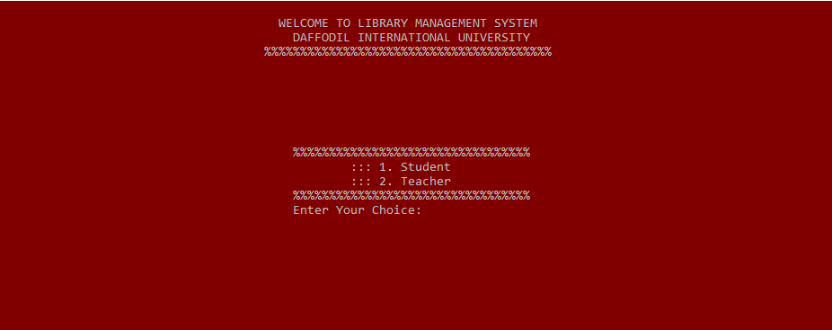

* 1. **login or sign up option**

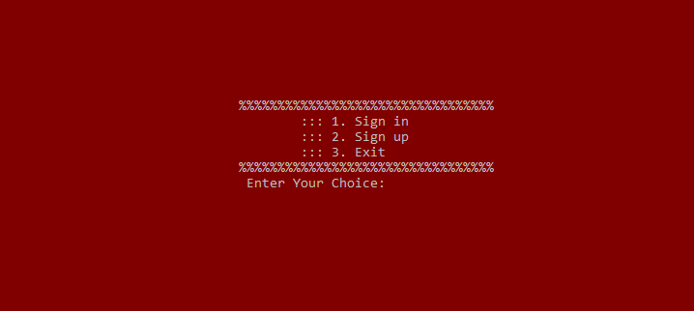

* 1. **Registration From**

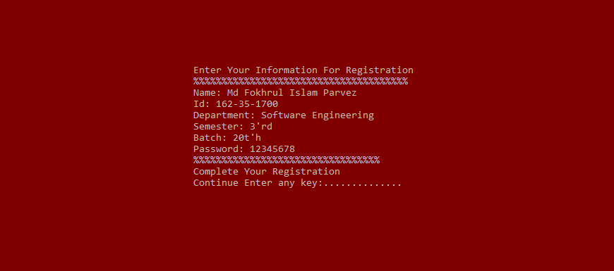

* 1. **Main Menu**

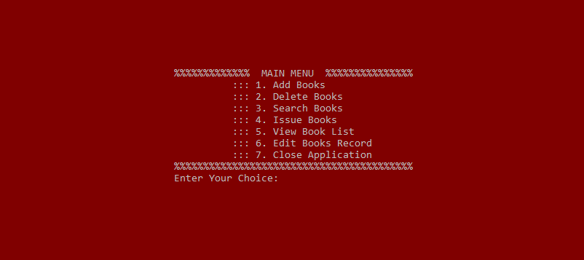

* 1. **Books Category**

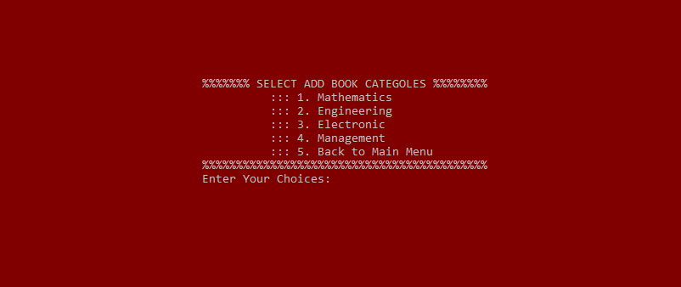

* 1. **Add Books**

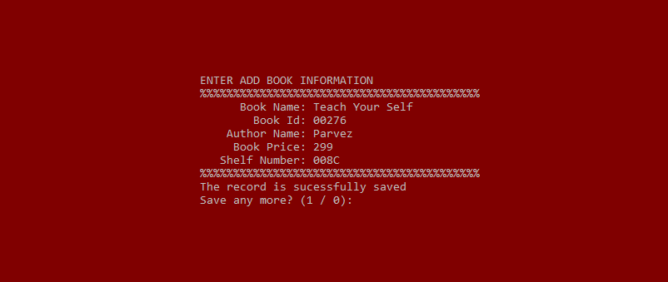

* 1. **Search Book**

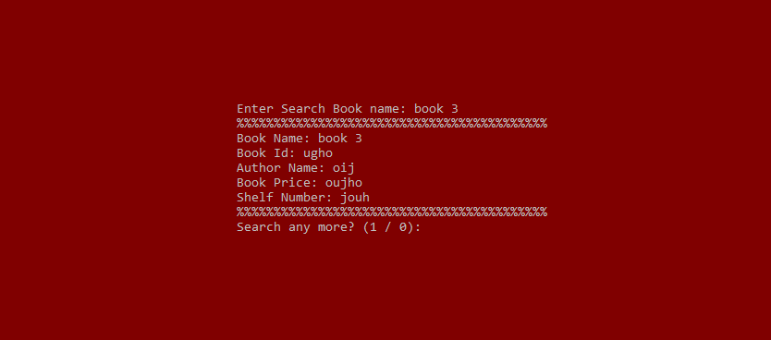

* 1. **View Book List**

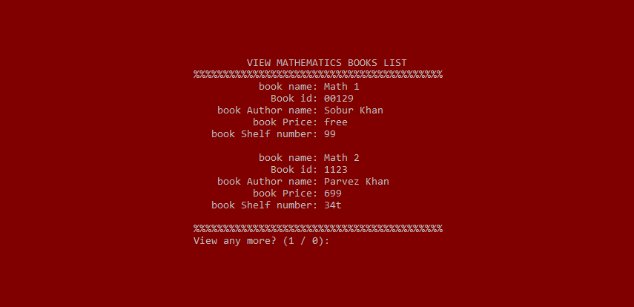

* 1. **Edit Book**

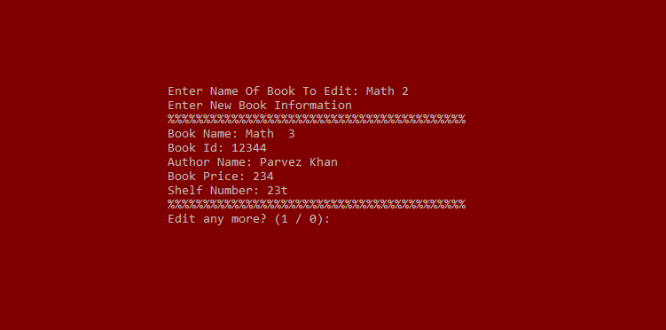

* 1. **Issue Book**

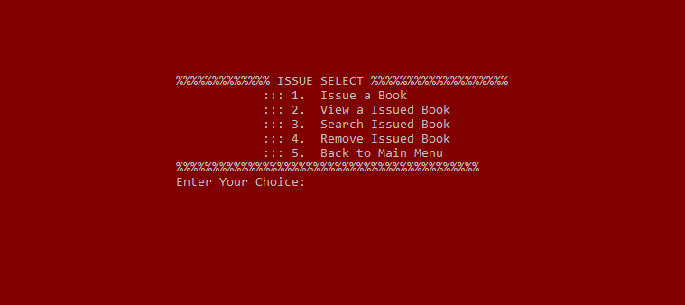

* 1. **Exit**

Enter any character then close the application.

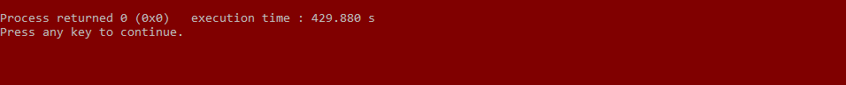

1. **CONCLUSION & FUTURE SCOPE**

**This website provides a computerized version of library management system which will benefit the students as well as the staff of the library.**

**It makes entire process online where student can search books, staff can generate reports and do book transactions. It also has a facility for student login where student can login and can see status of books issued as well request for book or give some suggestions. It has a facility of teacher’s login where teachers can add lectures notes and also give necessary suggestion to library and also add info about workshops or events happening in our college or nearby college in the online notice board. There is a future scope of this facility that many more features such as online lectures video tutorials can be added by teachers as well as online assignments submission facility , a feature Of group chat where students can discuss various issues of engineering can be added to this project thus making it more interactive more user friendly and project which fulfills each users need in the best way possible**

1. **REFERENCES**

[www.google.com](http://www.google.com)

[www.tutorialspoint.com](http://www.tutorialspoint.com)

books: -

* 1. Teach Your Self.
  2. Let Us C